Day 4: Dynamic Front-end “Way more”

*Sanity Data Component:*

Make component to fetch data from Sanity to display it on homepage. For this component I use reacthook, useState, useEffect. Use useEffect to fetch data from Sanity, and then use the map method to display the products according to my figma design.

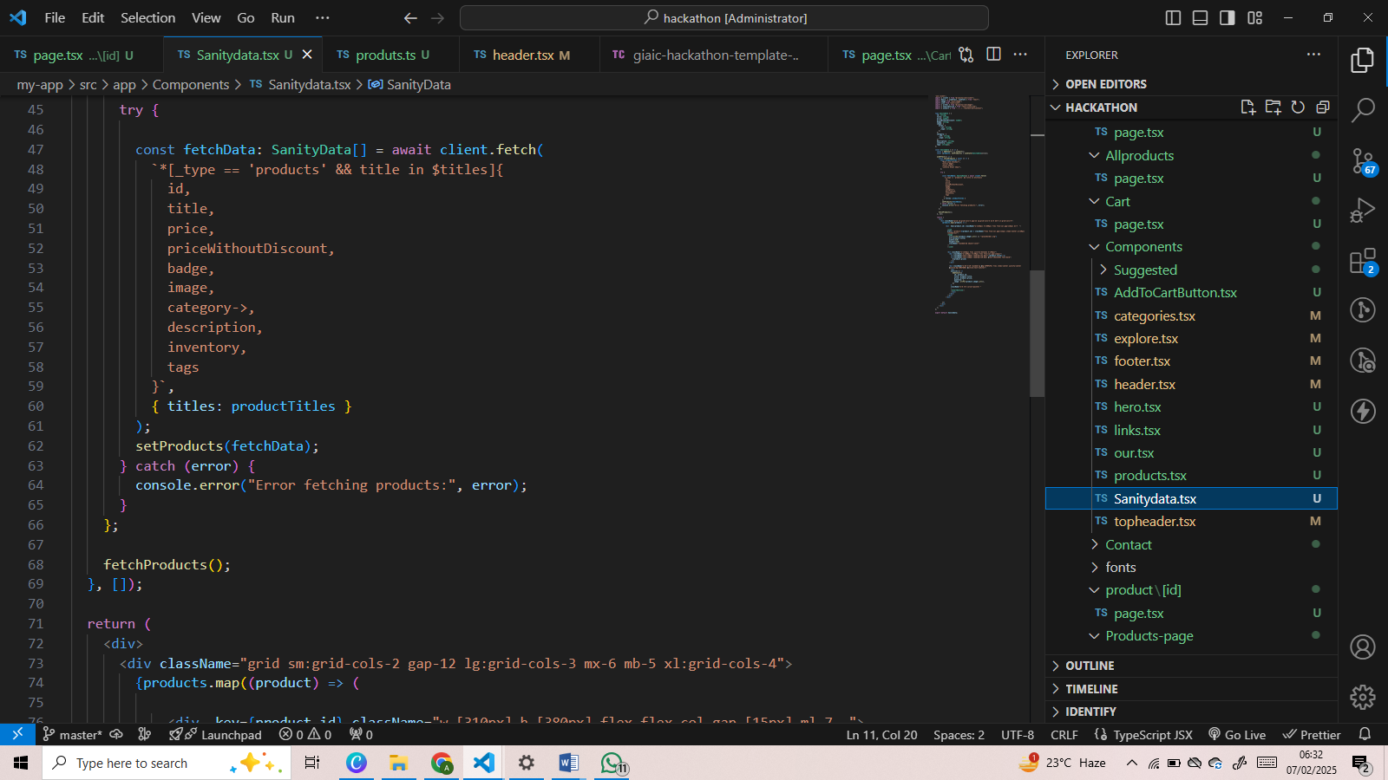

*Dynamic Route:*

I use nextjs dynamic routing using product unique id to fetch the products from sanity user id when any of the user click on the product, dynamic page will open .

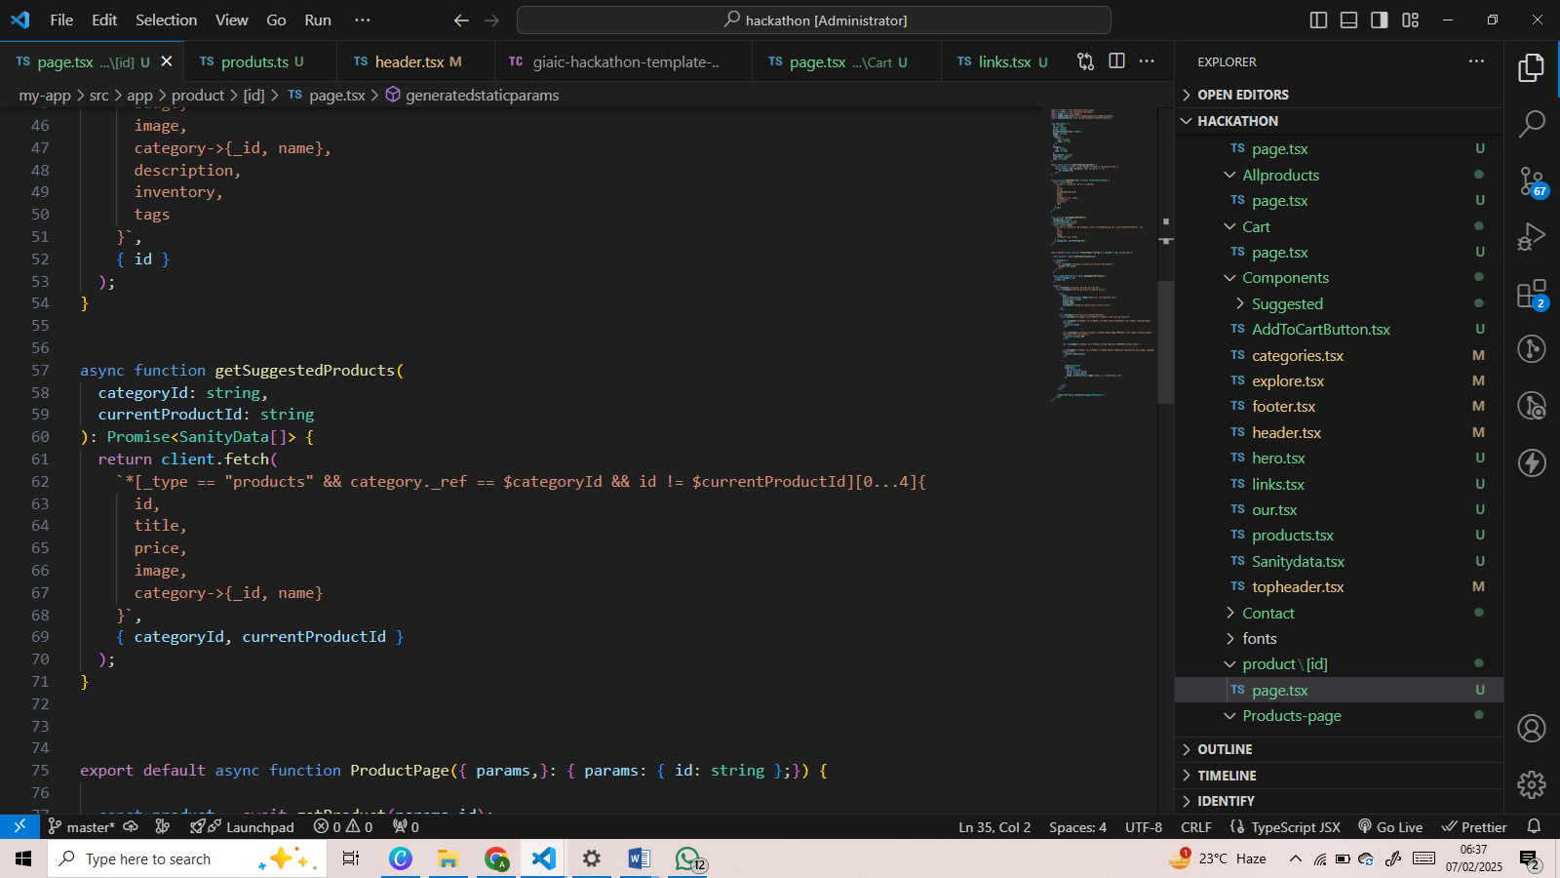

*Suggested Products:*

This component for the suggested products o n dynamic route relater to products category. It fetches the category item. You can see it bottom of your cart.

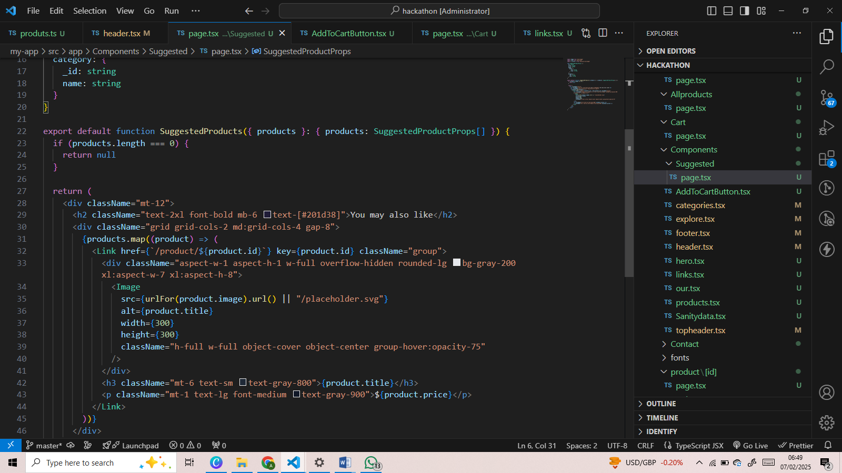

*Add to Cart Function:*

I make addtocartbutton component for AddtoCart function .

